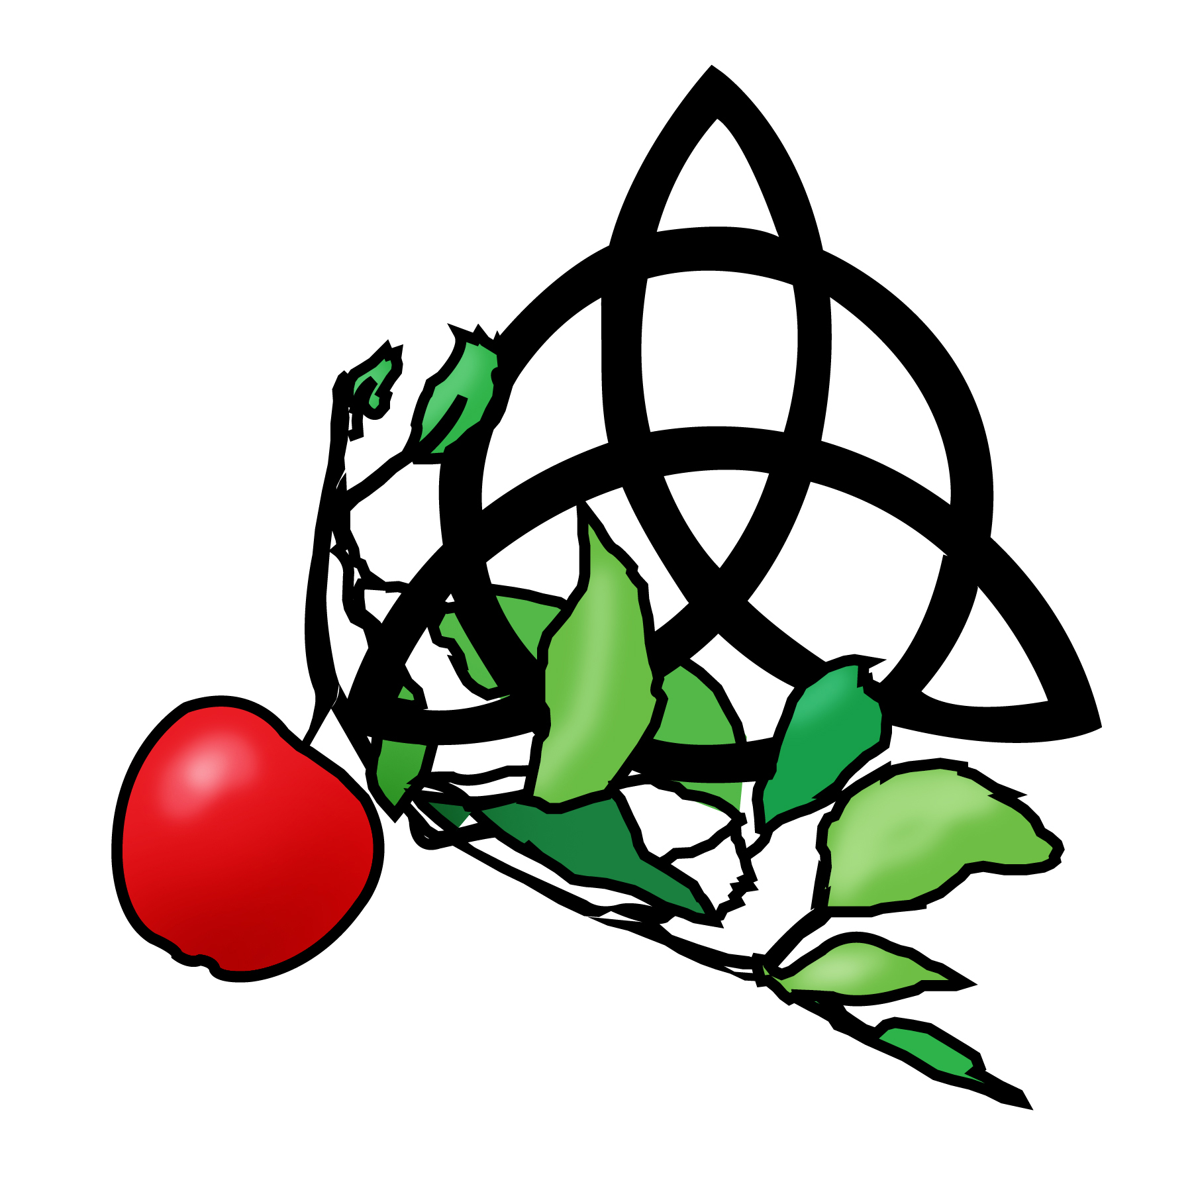

The Apple Branch – A Dianic Tradition
Dianic Faerie Craft

Application – please return to me at sorchablackbird@gmail.com

- Name:
- Address:

- Telephone #:
- Email address:
- Date of Birth:
- Name you use on Facebook:
- Sex:
- How long has the Goddess been an active part of your life?

- Do you feel called to public service on behalf of the Goddess, and why?

- What strengths will you bring to your work?

- Are there areas that you feel are weaknesses that you would you like to improve in yourself?

- What areas of study have you focused on and what would you like to learn more about?

- In what ways do you feel called upon to serve?

- Do you work full time?

- Do you have children at home?

- Are there any other areas of your life you would like to share?

The answers to this part will not disqualify you in any way but will serve to help me to understand you better and open lines of communication if any difficulties arise.
a) Do you suffer from any diagnosed chemical imbalance or mood disorder such as depression or bi-polar disease? Yes _____ No _____
Answer only if above question is responded to with a yes
b) Are you under the care of a physician or on medications for such as described above?
c) Do you feel that your emotional life is in balance and that you can participate fully in this program?

Please share anything else that you feel pertinent to establishing this relationship.

